CITY OF CHESTER
4th ANNUAL FALL FESTIVAL
SATURDAY, OCTOBER 16, 2021
2021 SPONSORSHIP PACKAGES

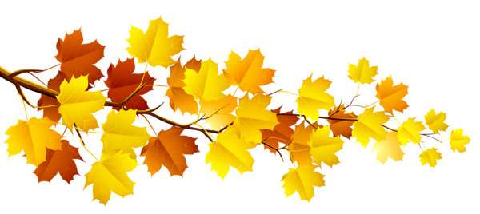CITY OF CHESTER
PARKS AND RECREATION
1330 SWANWICK STREET
CHESTER, ILLINOIS 62233
618-826-1430

4TH ANNUAL CITY OF CHESTER FALL FESTIVAL

Dear Potential Sponsor,
We are excited to be planning our 4th Annual Fall Festival. The purpose of the Fall Festival is to provide our residents and visitors with an exceptional event that makes them proud to be part of this community while generating tourism from the surrounding areas. The Fall Festival is a major component in our goal of becoming an event destination in the community.
We ask that you look through this sponsorship packet and consider investing in the Fall Festival. Please review the various levels and details and let us help you find the right fit. We have opportunities for businesses, organizations, families and individuals that will fit all budgets. If you don’t see the perfect fit, we will be delighted to create a package that meets your goals and budget.
Your support is crucial in helping us grow the festival and in bringing new attractions and activities each year. We would love to hear your ideas on helping us do just that. Please feel free to contact me at 618-826-1430 or email chesterrecreation@chesterill.com to discuss options or if you simply have questions. Thank you for your time and for considering the Fall Festival as part of your marketing strategy.
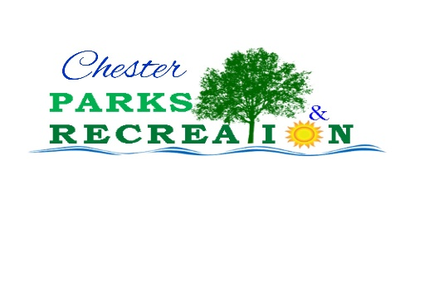
Most Sincerely,
Patti Carter
Patti Carter
Recreation Director

ABOUT THE FALL FESTIVAL
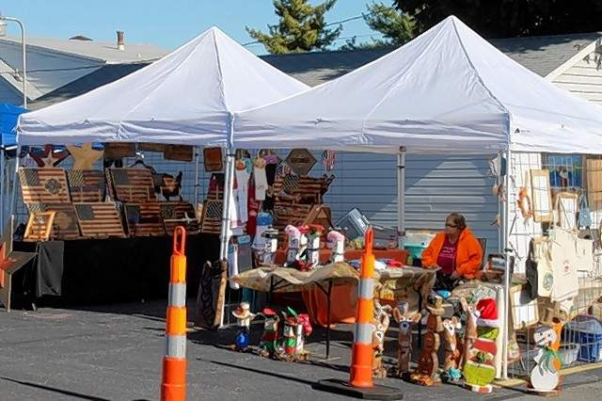
The Fall Festival was started in 2018 with only 20 craft booths, some games and a food vendor. In 2019 we grew to 36 vendors, a DJ, food vendors, inflatables and games. In 2020, in spite of COVID, we restructured our activities to ensure a safe event. We had 51 vendors, a DJ, food vendors, games and a drive in. Our plans this year include the Kid Zone where you can bounce, jump and slide in the inflatables, play a couple carnival games, get your face painted and compete in contests. We want to offer a shopping experience that is second to none with unique gifts, handmade and homemade items, jewelry, pottery, soap, candles, food, and décor, one of a kinds, flea market, toys, educational items, treats for your furry friends and more!
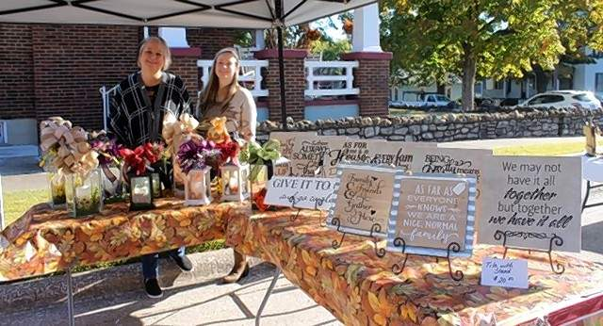

We want to grow our food stands. We hope to boast at least 3 food stands and 4 snack vendors this year. We want our attendees to enjoy a wide a variety of food. Everything from barbecue to funnel cakes, corn dogs to cotton candy, ribeye sandwiches to lemon shake ups, Italian beef to caramel apples, walking tacos to pumpkin latte…the list is endless! If you are a Farmers Market fan you can even pick up some fantastic produce from our market vendors.
This year’s festival is scheduled for Saturday, October 16, 2021 from 10 am-4 pm on Swanwick Street, near city hall.
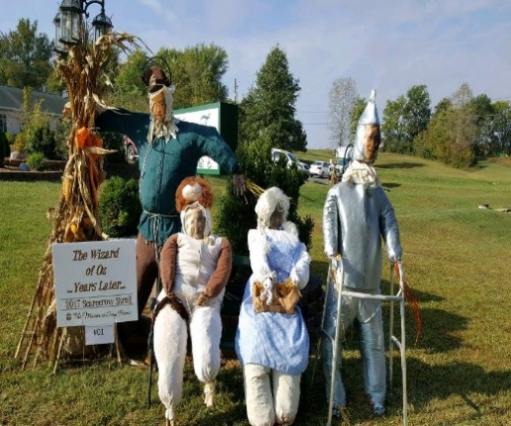
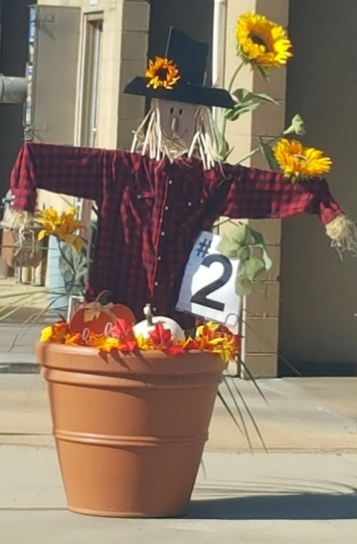
This festival improves every year and we plan to set the standard for festival family fun!

WHY SPONSORSHIP?

Event sponsorshiop is a critical component of a company or organization’s marketing plan. Sponsorship is a direct channel of communication, and it reaches people in an enfvironment that matches their lifestyle. The Cityof Chester offers a couple of successful events and the Fall Festival is one of them. The Fall Festival will provide you with an opportunity to place your product, image, or service in the hands of hundreds of potential customers.

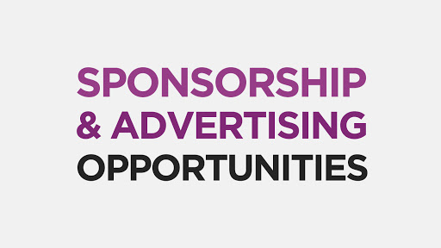
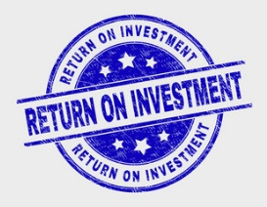
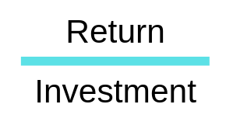
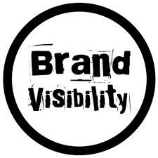
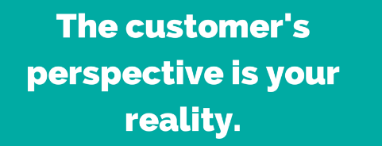
- Promote your business or organization
- Exposure to potential customers/clients
- Grow your client/customer base
- Increase market share
- Face-to-Face interaction with customers
- Enhance your image through community involvement and event association
- Networking opportunities
- Establish presence in the community
- Warm, fuzzies from participating in a great event!

OUR AUDIENCE

The Fall Festival attracts hundreds of attendees from not only Chester but the surrounding areas. Based on post-event follow up, we have determined that our audience is made up primarily of women ages 25-55 with children at home (she is a heavy consumer of mommy needs and a frequent poster on social media sites), families, seniors (enjoying their retirement and sharing word of mouth memories of their outings with their friends), couples, friends enjoying a “girls day” and the ever popular craft show aficionado. There common interests include recreation, education, home décor, food and cooking. They value a family atmosphere and expect a high-quality experience.
In addition to these groups, we have dads, antiquers, refurbishers, junkers and bargain hunters. Dads are typically “along for the ride” and prefer to watch rather than participate in activities. This means there is ample oportunity to chat and build a relationship with him or offer a promotion that will catch his attention. These men will make a beeline to a booth showcasing technology, home improvement products, gadgets, food and other manly things.
Festival goers like seeing the”oldie but goodie” vendors who return every year.
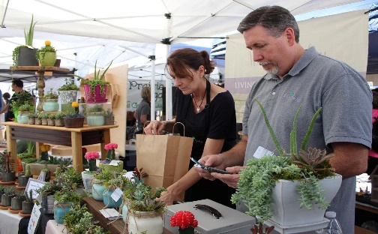
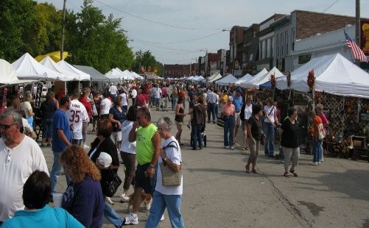

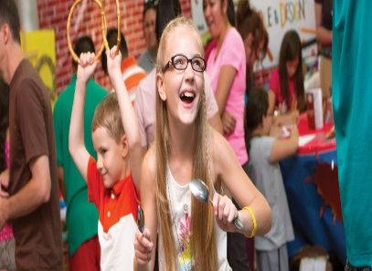
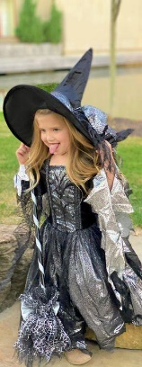
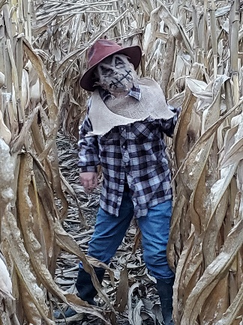

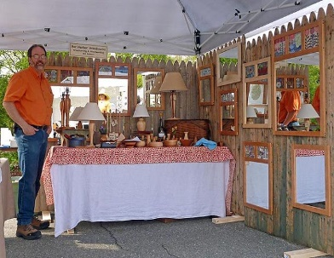

MARKETING PLAN

The Fall Festival information will be available on our website, www.chesterill.com. Thirty (30) days prior to the festival we will begin listing sponsors and vendors on the website.
We are able to reach over 8000 with our Facebook pages. We will share your sponsorship gift on our pages and we will share a business info post for each of our sponsors beginning thirty (30) days prior to the event.
Targeted email will be shared with vendors, businesses, volunteers, etc.
We will distribute flyers across Randolph County, Illinois and Perry County, Missouri.
We will advertise with the following print media agencies: the County Journal, the Perryville Republic Monitor and the North County News.
We will share press releases with the following: the County Journal, the Perryville Republic Monitor, the North County News, SunTimes News and KSGM.
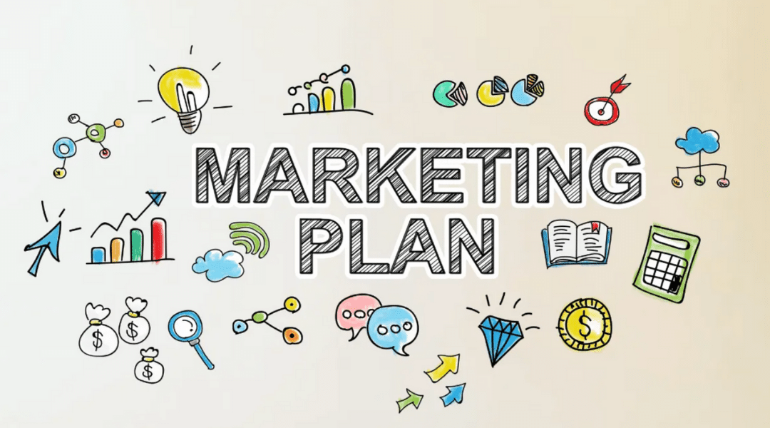

LEVELS OF SPONSORSHIP

KID ZONE We hope to have sponsors for each activity in the KID ZONE which will make every activity or event there FREE for the kids.

GOLDEN PUMPKIN $200 Your business name will be displayed as the sponsor of one of the inflatables. Space allows us to have 4 inflatables.
SILVER GOURD $100 Your sponsorship will cover the cost of a carnival game and the prizes needed to operate it. Your name will be displayed as the sponsor.
BRONZE SQUASH $ 50 This level of sponsorship gets your business name on the Kid Zone Sponsor Board. Your contribution will assist with the cost of prizes and any inflatables or games not sponsored.
HARVEST SPONSOR $150 A VIP sponsorship for businesses. This sponsorship includes a 3’ H x 4’w mesh banner, with your logo, to be displayed at the information tent.
PUMPKIN SPICE SPONSOR $100 For the business that is curious to see if this event is a good fit for you. A good budget fit.
STRAW HAT SPONSOR $ 50 This level of sponsorship is good for the business or organization that wants to be associated with the event and get their name out he community.
PITCHFORK SPONSOR $25 This level of sponsorship is for individuals and families that want to “pitch” in and help support the event and the community.
Our sponsors will all be listed on the On-Site Sponsor Board.
Golden Pumpkin, Silver Gourd and Harvest Sponsors will receive stage mentions throughout the day.
Golden Pumpkin and Harvest Sponsors may display free standing banners on site with placement approval.
Sponsors may submit a logo to be printed on our maps and schedules. This logo must be received by August 20, 2021
CONTACT INFORMATION
For additional information regarding sponsorship opportunities, please contact:
Patti Carter
City of Chester, Recreation Director
(618) 826-1430 ● chesterrecreation@chesterill.com ● www.chesterill.com
SPONSOR REGISTRATION
BUSINESS NAME
CONTACT NAME |  |  |  | PHONE
ADDRESS
CITY |  | STATE |  | ZIP CODE
EMAIL ADDRESS

LEVEL | AMOUNT | SELECT
GOLDEN PUMPKIN | $200
SILVER GOURD | $100
BRONZE SQUASH | $50
HARVEST SPONSOR | $150
PUMPKIN SPICE SPONSOR | $100
STRAW HAT | $50
PITCHFORK SPONSOR | $25
 | TOTAL DUE
DO NOT WRITE IN THIS AREA
LEVEL |  |  |  | AMOUNT |  | SELECT
GOLDEN PUMPKIN |  |  |  | $200
SILVER GOURD |  |  |  | $100
BRONZE SQUASH |  |  |  | $50
HARVEST SPONSOR |  |  |  | $150
PUMPKIN SPICE SPONSOR |  |  |  | $100
STRAW HAT |  |  |  | $50
PITCHFORK SPONSOR |  |  |  | $25
CHECK # |  | ACH | CASH |  | OTHER |  | AMOUNT |  |  | DATE

ATTACH LOGO HERE

