CITY OF CHESTER FALL FESTIVAL 2021

|  |  |  |  |
| --- | --- | --- | --- |
| **BUSINESS/GROUP NAME** | |  | |
| **CONTACT NAME** | |  | |
| **ADDRESS** | |  | |
| **PHONE** | |  | |
| POT | LOCATION | | 1ST, 2ND AND 3RD  CHOICE |
| 1 | OLIVE STATUE RIGHT SIDE | |  |
| 2 | OLIVE STATUE LEFT SIDE | |  |
| 3 | FISHER, KERKHOVER, COFFEY & GREMMELS LAW OFFICE | |  |
| 4 | AFSCME BLDG. STATE STREET | |  |
| 5 | VFW | |  |
| 6 | CAR WAS CHURCH & STATE | |  |
| 7 | MISSISSIPPI VALLEY ART GUILD | |  |
| 8 | RUB A DUB LAUNDRY STATE & OPDYKE | |  |
| 9 | BLAZING COLOR LIGHT & STATE STREET | |  |
| 10 | ARBEITER’S LAW OFFICE STATE STREET | |  |
| 11 | SUBWAY RESTAURANT | |  |
| 12 | CHESTER NATIONAL BANK STATE & E. STACEY | |  |
| 13 | TAYLOR’S TREASURE’S THRIFT STORE | |  |
| 14 | CHESTER INSURANCE AGENCY SWAWICK & E. STACEY | |  |
| 15 | COLVIS INVESTMENT SWANWICK & E. STACEY | |  |
| 16 | VINTAGE MARKET SWANWICK STREET | |  |
| 17 | COLOR XPRESSIONS SWANWICK STREET | |  |
| 18 | FASHION FLAIR STYLING SALON | |  |
| 19 | LUCKY LARRY’S SWANWICK & W. HOLMES | |  |
| 20 | ROWOLD HARDWARE SWANWICK & W. HOLMES | |  |
| 21 | HARDEE’S SWANWICK & W. HOLMES STREET | |  |
| 22 | BLUTO STATUE SWANWICK & W. HOLMES | |  |
| 23 | POST OFFICE SWANWICK STREET | |  |
| 24 | CITY HALL SWANWICK STREET | |  |

ADOPT A POT

|  |  |  |  |
| --- | --- | --- | --- |
| SELECT ONE | INDIVIDUAL | BUSINESS | ORGANIZATION |
| CONTACT NAME |  | | |
| PHONE |  | | |
| ADDRESS OF DISPLAY |  | | |
| MAILING ADDRESS |  | | |
| POT NUMBER |  | | |



WAIVER AND RELEASE OF ALL CLAIMS AND ASSUMPTION OF RISK

 Please read this information carefully and be aware that in signing the form and participating in this event, you will be expressly assuming the risk and legal liability and waiving and releasing all claims for injuries, damages or loss which you might sustain as a result of participating in any and all activities connected with or associated with the Fall Adopt A Pot Program.

I recognize and acknowledge that there are certain risks of physical injury to participants in this event and I voluntarily agree to assume the full risk of any injuries, damages or loss, regardless of severity, that I may have (or to accrue to me) as a result of participating in this event against the City of Chester, including their officials, agents, volunteers, employees, and sponsors.

I do hereby fully release and forever discharge the City of Chester, including their officials, agents, volunteers, employees, and sponsors from any and all claims for injuries, damages or loss that I may have, or which may accrue to me and arising out of, connected with, or in any way associated with this event.

By signing this entry form, I understand that the City of Chester may use photographs of the pots and names of participant(s) for publicity and promotion. Participant(s) agree to leave pots on display October 15th – October 31st. The City of Chester is not responsible for lost, stolen or damaged items.

I acknowledge that I have the right to sign this document for my child, my ward, family, group, organization, or business, and I do hereby agree that I have read and I agree to the CONTEST RULES.

My signature below indicates that I have read and agree to the Waiver and Release of All Claims and Assumption of Risk Form and the Contest Rules and Photo Release.

|  |  |
| --- | --- |
| PRINTED NAME |  |
| SIGNATURE |  |
| DATE |  |

CITY OF CHESTER FALL FESTIVAL 2021

ADOPT A POT

RULES AND REGISTRATION INFORMATION

SATURDAY, OCTOBER 16, 2021

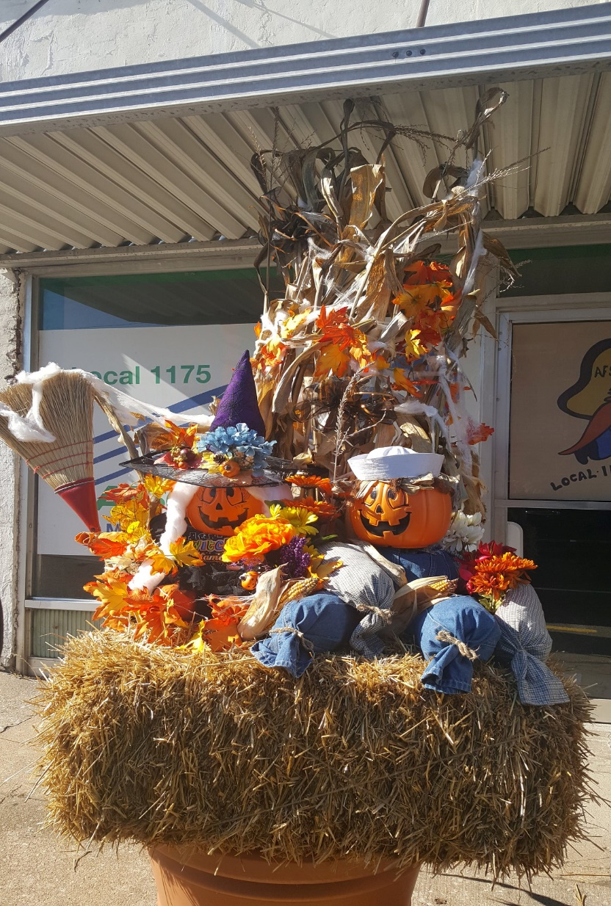

CITY OF CHESTER FALL FESTIVAL 2021

ADOPT A POT

**OFFICIAL CONTEST RULES**

1. REGISTRATION

a. Registration begins September 1, 2021.

b. Registration packets are available at Chester City Hall.

c. The Registration Packet will include a number that must be displayed on your entry.

2. You may begin decorating your pot October 1,2021 and it must be complete by 9 a.m., Wednesday, October 13, 2021.

3. Do not move the pot.

4. Do not remove dirt.

5. Do not add sand.

6. Entries must be family friendly and appropriate. Entries that are deemed inappropriate by Park and Recreation staff will be disqualified and removed.

7. There are only 24 pots available.

8. The City of Chester is not responsible for anything damaged, lost or stolen. Do not put out valuables and make sure to securely fasten all props.

9. All participants agree to allow the use of their name(s) and photos for promotional purposes and in any form of publication.

10. JUDGING

a. All pots must be tagged with an entry number that must be made visible for judging purposes.

b. Judging will be done by a group of independent judges.

c. Judging will begin October 13th at 9 a.m.

d. All decisions of the judges are final.

11. Winners will be announced at the Fall Festival, Saturday, October 16th at 3 p.m. You need not be present to win. Winners will be contacted Monday, October 18th.

12. First ($50), Second ($25) and Third Place ($15) cash prizes will be awarded.