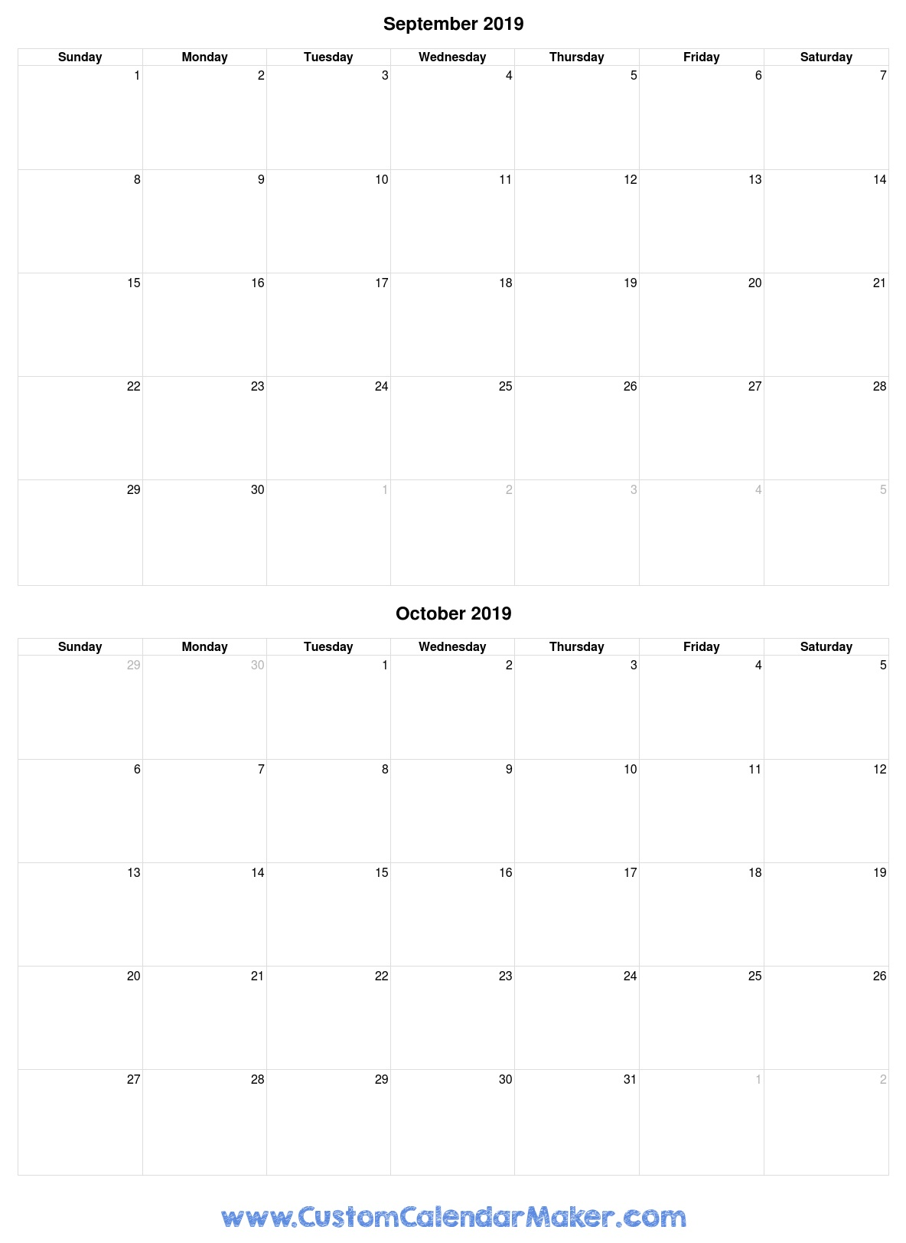

Practice 6-7 pm

AWARDS 7 pm

Practice 6-7 pm

Practice 6-7 pm

Practice 6-7 pm

Practice 6-7 pm

Practice 6-7 pm

Games 4-4:50 & 5-5:50 pm

Games 4-4:50 & 5-5:50 pm

Games 4-4:50 & 5-5:50 pm

Games 4-4:50 & 5-5:50 pm

Practice 4-5:30pm

Practice 4-5:30pm