2019 Golf Fundraiser
The golf team will be having their one and only fundraiser Saturday, June 29, 2019, by hosting their annual benefit golf tournament. For those that are unable to participate in the tournament, we are also accepting monetary donations. Last year the CHS golf program was able to purchase team golf bags for the varsity boys and girls.
Any donations are appreciated. Please feel free to select an amount below or choose your own amount.
The Chester Golf Team and their coaches appreciate your support!
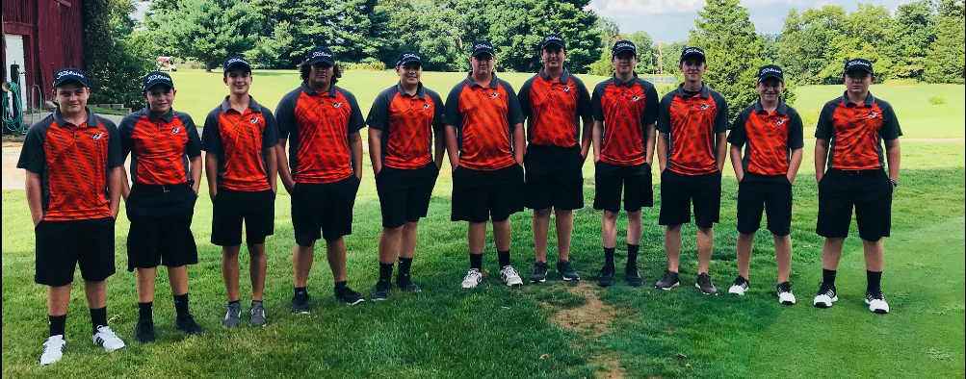
2018 Golf Team
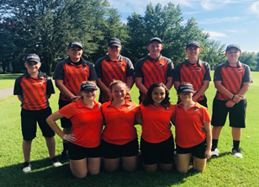
-----------------------------------------------------------------------------------------------------------------------------------------
Name: ___________________________________________________________
Address: _________________________________________________________
Donation amount:
_____$10 _____$15 _____$20 ______$25 ______$30 _______ Other
(Checks may be made out to CHS Golf Team and sent to Paul Zemlyn, 210 Edna St., Chester, IL 62233)
THANK YOU FOR YOUR SUPPORT OF CHESTER HIGH SCHOOL GOLF!

