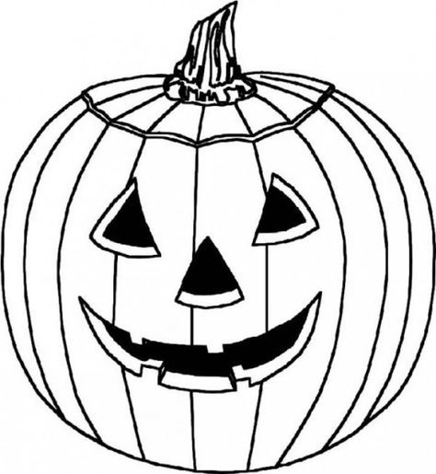
PUMPKIN CARVING CONTEST
FALL FESTIVAL 2019
DIVISIONS AND CATEGORIES:
10 YEARS & UNDER: SILLIEST JACK & MOST TRADITIONAL JACK
11-17 YEARS: SILLIEST JACK, MOST TRADITIONAL JACK &
CREEPIEST JACK
18 AND OVER: SILLIEST JACK, MOST TRADITIONAL JACK, CREEPIEST JACK AND “GOOD GOURD JACK”

ENTRY RULES

- PICK UP A PUMPKIN PACKET (CITY HALL)  - COMPLETE AN ENTRY FORM  - TURN IN ENTRY FORM (CITY HALL)  - DELIVER COMPLETED PUMPKIN ENTRY TO THE PUNKIN’ PATCH AT THE FALL FESTIVAL, SATURDAY, OCTOBER 19TH, 9-10 AM.  - ENTRIES NOT CHECKED IN BY 10 AM WILL BE DISQUALIFIED.  - CARVED PUMPKINS DEEMED INAPPROPRIATE WILL NOT BE JUDGED OR DISPLAYED.  - DO NOT PUT YOUR NAME ON YOUR PUMPKIN. YOU WILL BE GIVEN A NUMBER IN YOUR PUMPKIN PACKET.  - BATTERY OPERATED LIGHTING OR A GLOWSTICK ONLY. NO REAL FLAME.  - WINNERS WILL BE ANNOUNCED AT 3 PM. NEED NOT BE PRESENT TO WIN. | - ONLY 1 ENTRY PER CONTESTANT  - PUMPKINS MUST BE REAL (NO PLASTIC OR FAKE PUMPKINS ALLOWED)  - CARVING/DECORATION MUST BE COMPLETED PRIOR TO DELIVERY.  - STENCILS ARE ALLOWED AND PARENTS ARE WELCOME TO HELP: HOWEVER, PUMPKINS SHOULD RELFLECT THE AGE AND ABILITIES OF THE CHILD.  - ALL ENTRIES WILL BE JUDGED BASED ON DESIGN, DETAIL, CREATIVITY AND ORIGINALITY.  - JUDGES DECISIONS RE FINAL.JUDGING WILL TAKE PLACE BETWEEN 10:30 AM AND 1 PM.  - PUMPKINS WILL BE DISPLAYED AT THE PUNKIN’ PATCH, 9 AM-3 PM, SATURDAY, OCTOBER 19TH.  - PUMPKIN PICK UP IS 3-4 PM. ANY ENTRIES LEFT AT 4 PM BECOME THE PARK AND RECREATION DEPARTMENT’S PROPERTY AND WILL BE DISPOSED OF.

PUMPKIN CARVING CONTEST
FALL FESTIVAL 2019

WAIVER AND RELEASE

Please read this information carefully and be aware that in signing the form and participating in this event, you will be expressly assuming the risk and legal liability and waiving and releasing all claims for injuries, damages or loss which you or your minor child/ward might sustain as a result of participating in any and all activities connected with or associated with this event.

I recognize and acknowledge that there are certain risks of physical injury to participants in this event and I voluntarily agree to assume the full risk of any injuries, damages or loss, regardless of severity, that I my minor child/ward or I may have as a result of participating in this event against the City of Chester, including their officials, agents, volunteers, employees, and sponsors.

I do hereby fully release and forever discharge the City of Chester, including their officials, agents, volunteers, employees, and sponsors from any and all claims for injuries, damages or loss that I or my minor child/ward may have, or which may accrue to me and arising out of, connected with, or in any way associated with this event.

I understand and agree that pictures of myself (or my minor child) and my/their pumpkin may be used as promotional material and advertisements in print, social media and online.

My signature below indicates that I have read and agree to the Waiver and Release of All Claims and Assumption of Risk Form and, if signing for a minor, I am the legal parent of guardian of said minor.

PARTICIPANT SIGNATURE: ___________________________________________

PARTICIPANT PRINTED NAME: ___________________________________________
DATE: _____________________

PARENT SIGNATURE: (IF UNDER 18 YEARS) ___________________________________________
PARENT PRINTED NAME: ___________________________________________
DATE: ______________________
ENTRY NUMBER: ____________

