Autism Awareness
Annual Golf Tournament at Chester Country Club
May 26, 2018
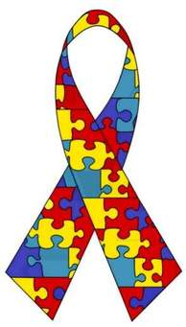

Team Sponsor $260
(consists of 4 person scramble)
Hole Sponsors:
Gold $250.00
Silver $100.00
Bronze $50.00

Hole Sponsors will consist of a sign at a tee box and name will appear on flyer in club house thanking you and your promoting business

Donated Items Appreciated

Dinner at Club House following Chester Autism Tournament

Hole Sponsors invited for meal
Chester Country Club
P.O. Box 166, Chester, IL 62233 / 618-826-3168
Contact Bob Fleming @ 618-559-9407

