Chester Country Club
AUTISM AWARENESS TOURNAMENT
SATURDAY, MAY 26, 2018
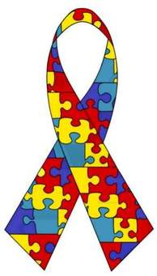
Shot Gun Start at 9 am
Entry Fee $260 Per 4 - Person Team
Cart Fee $25.00 Per Cart
Trail Fee $10.00 Per Cart
Hole Sponsors also appreciated:
618-559-9407(Bob Fleming)
Meal, included in entry fee, will follow play.
No Outside Beverages

Please return entry form and payment by May 10, 2018
Make all checks payable to Chester Country Club,
P.O. Box 166, Chester, IL 62233 / 618-826-3168
- Name: |  | - Name:
- Address: |  | - Address:
- Phone: |  | - Phone:
- Email: |  | - Email:

- Name: |  | - Name:
- Address: |  | - Address:
- Phone: |  | - Phone:
- Email: |  | - Email:

Carts Needed_________ Will Bring Cart________

