RiverBOAT Market

REGISTRATION FORM
(Please Print)
Today’s date:

vendor INFORMATION
Vendor’s last name: |  | First:
Street address: |  |  | Cell phone no: |  |  |  |  | Home phone no.:
 |  |  | ( ) |  |  |  |  | ( )
P.O. Box: | City: |  |  |  | State: |  |  |  | ZIP Code:
Item(s) for sale:

Market dates
Date | Riverboat | Sale Hours | Set Up Time | Registration Deadline |  | Select
July 28, 2018 | American Queen | 9:00 am-3:30 pm | 8:00 am | July 13, 2018
July 29, 2018 | American Duchess | 9:00 am-3:30 pm | 8:00 am | July13, 2018
August 15, 2018 | America | 9:00 am-11:45am | 8:00 am | July 31, 2018
September 1, 2018 | American Queen | 9:00 am-12:45 pm | 8:00 am | August 17, 2018
September 20, 2018 | Queen of Mississippi | 9:00 am-1:15 pm | 8:00 am | September 5, 2018
September 25, 2018 | American Queen | 9:00am-3:30 pm | 8:00 am | September 10, 2018
October 4, 2018 | Queen of Mississippi | 9:00 am-1:15 pm | 8:00 am | September 19, 2018
Total Selections
X $20 each
Total Due

Waiver and Release of All Claims and Assumption of Risk

Please read this information carefully and be aware that in signing the form and participating in this event, you will be expressly assuming the risk and legal liability and waiving and releasing all claims for injuries, damages or loss which you might sustain as a result of participating in any and all activities connected with or associated with this event.
I agree that I am expressly assuming the risk and legal liability and waiving and releasing all claims for injuries, damages or loss which I may sustain as a result of participating in any and all activities associated with this event.
I recognize and acknowledge that there are certain risks of physical injury to participants in this event and I voluntarily agree to assume the full risk of any injuries, damages or loss, regardless of severity, that I may have (or to accrue to me) as a result of participating in this event against the City of Chester, including their officials, agents, volunteers, employees, and sponsors. This includes damage, injury, theft or loss of any type from set up to removal of exhibits. All items offered for sale shall be items I have personally made/created or am permitted to sell.
I do hereby fully release and forever discharge the City of Chester, including their officials, agents, volunteers, employees, and sponsors from any and all claims for injuries, damages or loss that I may have, or which may accrue to me and arising out of, connected with, or in any way associated with this event.
My signature below indicates that I have read and agree to the Waiver and Release of All Claims and Assumption of Risk.

Signature_________________________________ Date_______________

Make checks payable to Riverboat Market. You will need a separate check for each market.

RULES and Guidelines

- A signed and returned application indicates your intent to comply with the following guidelines and rules.
- Please make sure to fill out your application fully and correctly for consideration.
- The registration fee must accompany your application.
- Vendors will receive confirmation of acceptance.
- Exhibitors must submit a clear written description of their work and or items to be displayed.
- Items will be limited in order to reduce duplication of items and to ensure a balanced show.
- The Recreation Director reserves the right to remove any item(s) not deemed suitable.
- No electricity is available.
- Registration fee is $20 and is refundable to every vendor remaining the entire show.
- Vendors leaving early will not be allowed back.
- The show will be held rain or shine. No cancellations unless the riverboat is cancelled. In the event the boat is cancelled your registration fee will be refunded.
- Vendors not showing up forfeit their registration fee.
- Each exhibitor will be responsible for his/her own protective covering, tables, and chairs, etc.
- Vendors should not arrive until set up time.
- Decisions of the Recreation Director are final.
- Keep you Vendor Card at your booth.
- If you have food items, you will need to contact the Randolph County Health Department.

~~~~~~~~~~~~~~~~~~~~~~~~~~~~~~~~~~~~~~~~~Do not write below this line~~~~~~~~~~~~~~~~~~~~~~~~~~~~~~~~~~~~~~~~~~~~

Date | Riverboat | Cash | Check Number | Date Received | Date Returned | Initialed
July 28, 2018 | American Queen
July 29, 2018 | American Duchess
August 15, 2018 | America
September 1, 2018 | American Queen
September 20, 2018 | Queen of Mississippi
September 25, 2018 | American Queen
October 4, 2018 | Queen of Mississippi

Riverboat Market

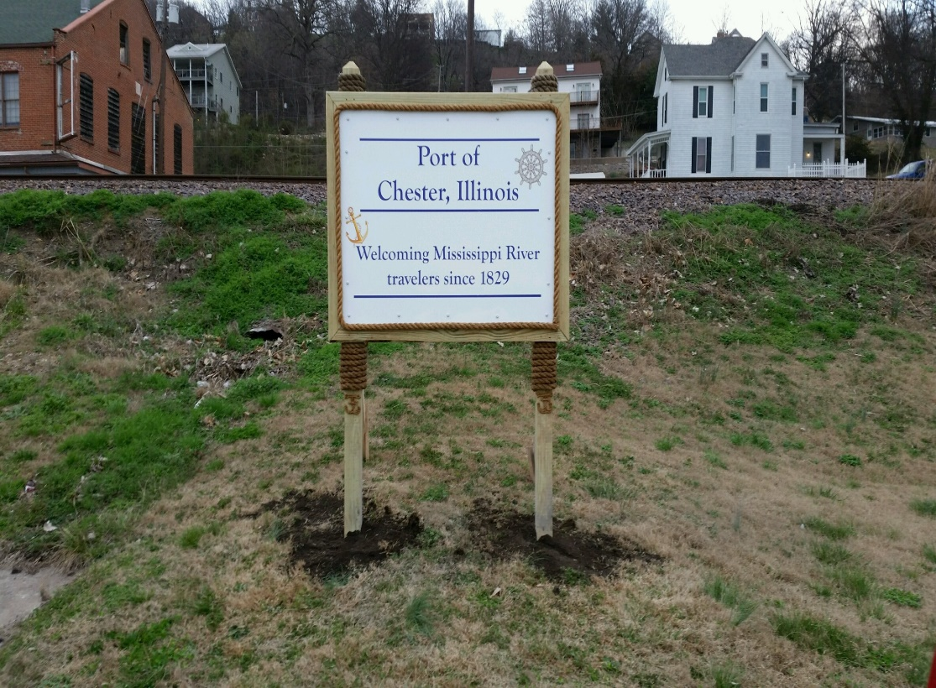
Vendor space will be available, at Chester Square Gazebo Park, during the touring times of the riverboats docking in Chester. Crafters and artists are invited to display and offer their wonderful art and hand crafted items, as well as Farmer’s Market items and party line items for sale.
Check the website for dates and deadline to register.
$20 Registration Fee per event. Refundable if vendor is present for the entire event.

For information:

618-826-1430
chesterrecreation@chesterill.com
www.chesterill.com

