The Stone Cottage Market
Chester, IL
Collectibles, Antiques, Crafts, and Food
Saturday, October 21, 2017
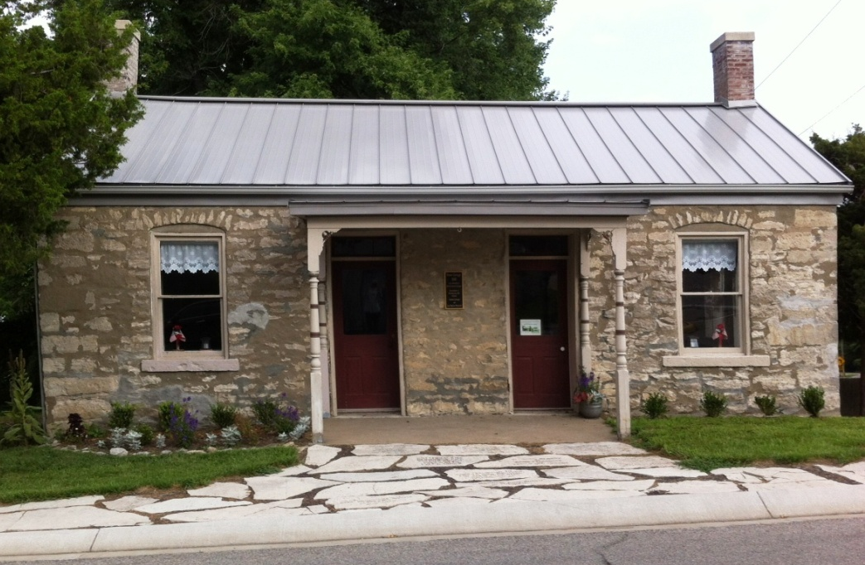
9 - 3

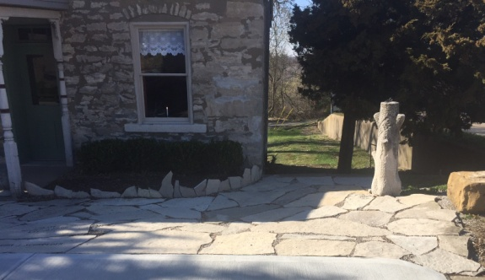
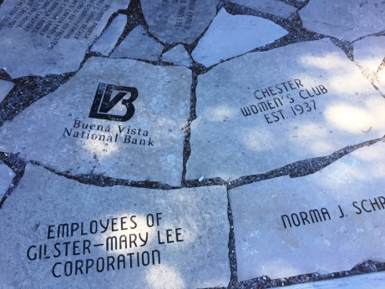

Custom Engraved Stone orders accepted the day of the sale:
Choose a stone and its location
Limited number of stones available
Maximum number of letters in names determined by size of stone
$200 per stone
$25 each additional line

The Old Stone Cottage (ca 1850) is located on Chestnut Street two doors north of the Randolph County Courthouse in Chester, IL. Renovation began the summer of 2010 with the objective to create a small museum in this historic home. A small group of devoted volunteers have accomplished much: New guttering, painting, tuck pointing and clearing of vines and brush.
A special note of appreciation to the First Christian Church for their assistance with the Stone Cottage Market.

