St. John Chester Annual
PTL Spaghetti Dinner

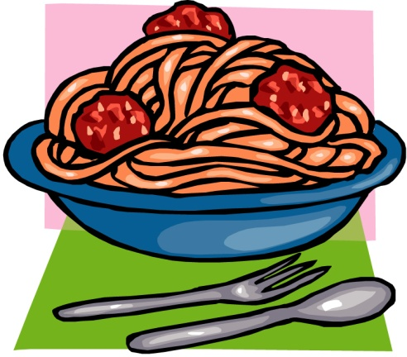

Wednesday, March 15, 2017

4:00 – 6:30 pm

St. John Parish Hall, Chester, IL

Call ahead for carry-outs 618-826-4769

Meal includes: All you can eat spaghetti with meat sauce, salad, garlic bread, dessert and a drink.

Adults: $8.00
Children (ages 5-12) $5.00

Children under age 4 are free for dine in only.

