COPS AND KIDS AT CHRISTMAS
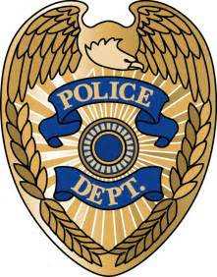
Chester Police Department, Red Bud Police Department, Steeleville Police Department and the Randolph Country Sheriff’s Office
In Partnership with Chester Wal-Mart
December 17th, 2017
The Chester Police Department, Red Bud Police Department, Steeleville Police Department and the Randolph County Sheriff’s Office are now accepting donations for our 1ST annual Cops and Kids at Christmas program. The program provides families in need this holiday this season the opportunity to go holiday shopping with a member of local law enforcement.
The holiday event partners officers and deputies with each child as they shop for gifts. The program hopes to build a solid relationship between law enforcement and children, teaching them that a police officer can be a resource for advice and also be there when they need a friend. This partnership fosters a bond that will hopefully remain with the child throughout their life.
We would like to ask for your help to make this Christmas one to remember for the less fortunate children of our communities. Donations can be dropped off at the Chester Police Dept. Red Bud Police Dept. Steeleville police Dept. and the Randolph County Sheriff’s Office. Arrangements can also be made to pick up the donations. Please make checks payable to one of the above listed police departments C/O Cops and Kids at Christmas. Thank you for your consideration.

