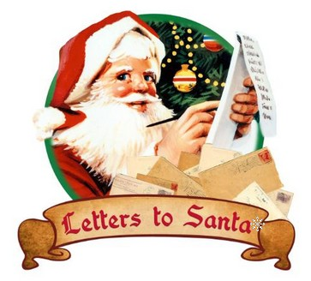

Do you want to write Santa a letter and want to be sure that it makes it into his hands? We can help! The City of Chester has made special arrangements with the North Pole so that your child will receive a personalized letter from Santa!
Letters may be dropped off to the special mailbox, in the City Hall lobby, during the facility’s normal hours, beginning Monday, December 7th and ending Friday, December, 18th at 3:30 pm.
The elves will take the letters back to Santa, at the North Pole and children may pick up their return letters December 21 – 23, during normal hours.
PARENTS may pick up their information form at City Hall or by visiting www.chesterill.com or request through email at chesterskateland@hotmail.com.
Sponsored by the City of Chester Recreation
618.826.1430

